**The Battle of Neighborhood**

Emma Feng

February 8, 2021

**1. Introduction**

**1.1 Background**

Perth is the capital and largest city of the Australian state of Western Australian. Perth is one of the most successful diverse cities in the world, because of which, a rich variety of cuisines from different backgrounds has been adopted and developed. For example, even in a small neighborhood, you can find many different types of restaurants- Chinese, Italian, Indian, Mexican, Thai, Japanese……you name it! If you are passionate with business in food industry, like opening a restaurant, you might have to accept a reality- the competition is quite tough.

**1.2 Problem**

One of our clients, Mr. Romano who is an immigrant from Italy, has great passion in opening an Italian restaurant in Perth city center. But there are already so many restaurants in the city. Where is the best location to open an Italian restaurant?

**1.3 Solution**

In order to help Mr. Romano with the solution, we will use data science power to generate some promising neighborhoods. And then, he can choose one of them as the best location for business value. The locations we are looking for have to meet at least three criteria- as close to city center as possible, not already crowded with restaurants and without Italian restaurants in vicinity.

**2. Data**

**2.1 Important factors and data sources**

Based on the definition of the problem, factors that might impact our decision are:

* Number of the existing restaurants in the neighborhood
* Number of the existing Italian restaurants in the neighborhood
* Distance of the neighborhood from the city center

Following data sources will be needed to extract the required information:

* Centers of hexagon neighborhoods will be generated algorithmically and approximate address of centers of those areas will be obtained using ‘geopy.geocoders’
* Restaurants data including number, type and location in every neighbohood will be obtained using Foursquare API
* Coordinate of Perth center will be obtained using ‘geopy.geocoders’

**2.2 Create neighborhood candidates**

Before we create neighborhood candidates, we should first find the latitude and longitude of Perth city center, using well known address-Hay Street Mall and geopy.geocoders.

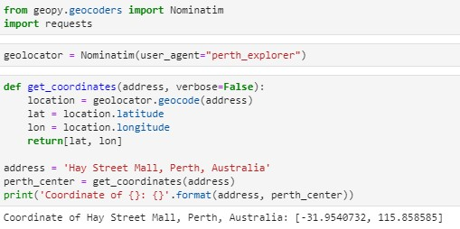

Figure 1

We discover that the latitude and longitude of Perth city center (Hay Street Mall) are -31.9540372 and 115.858585 (Figure 1).

Next, we will create a grid of neighbohood candidates, equally spaced, centered around city center and within ~6km from Hay Street Mall. Our neighborhoods will be defined as circular areas with a radius of 300 meters.To accurately calculate distances we need to create functions to convert between WGS84 spherical coordinate system (latitude/longitude degrees) and UTM Cartesian coordinate system (X/Y coordinates in meters). Then we'll project those coordinates back to latitude/longitude degrees to be shown on Folium map.

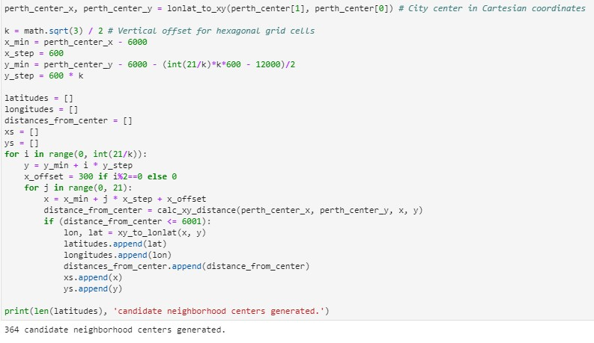

Figure 2

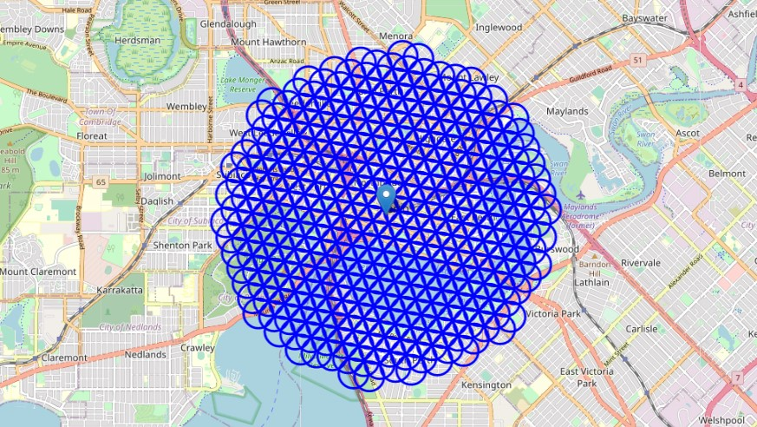

Figure 3

We observe that a grid of 364 candidate neighborhood centers generated (figure 2, figure 3). Then, we use the geopy.geocoders to get their approximate addresses (figure 4).

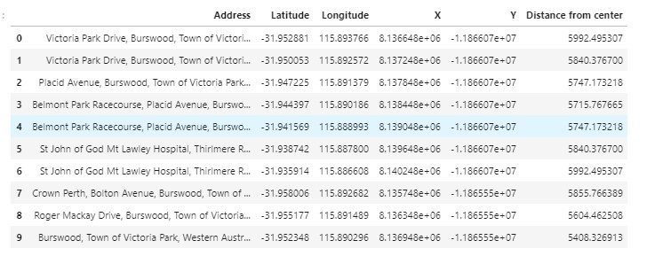

Figure 4

**2.3 Use Foursquare API to get restaurant data**

By using Foursquare API to get information about the restaurants in each candidate neighborhood, we discover the following data:

* Total number of restaurants: 362
* Total number of Italian restaurants: 24
* Percentage of Italian restaurants: 6.63%
* Average number of restaurants in neighborhood: 2.2747252747

(figure 5)

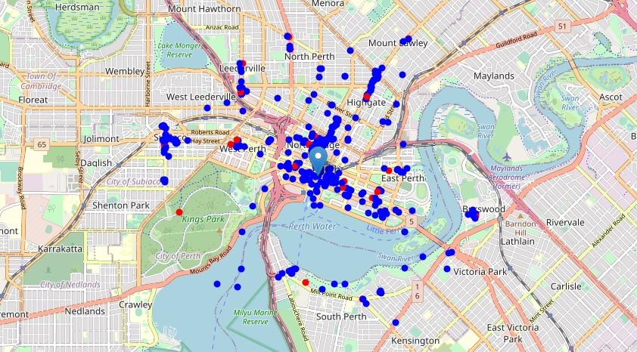

Figure 5. Italian restaurants in red and others in blue